ФОТОДОКУМЕНТАЦИЯ
Second European Conference on Information Literacy (ECIL 2014)
20 October 2014, Dubrovnik, Croatia
Opening Ceremony
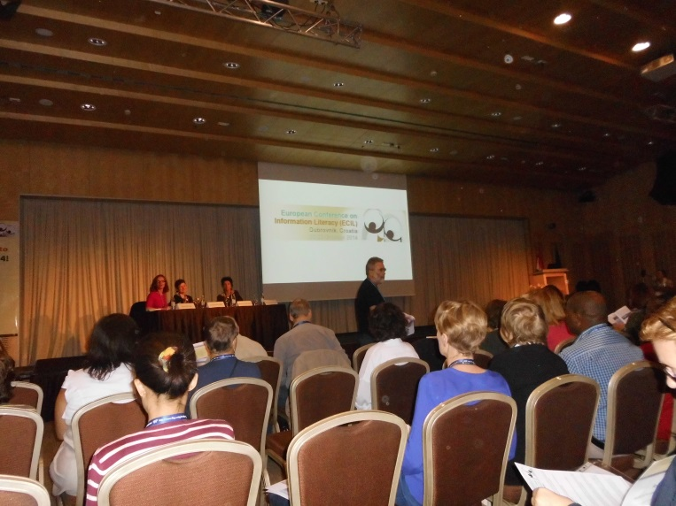
Prof. Dr. Serap Kurbanoglu – Opening Speach
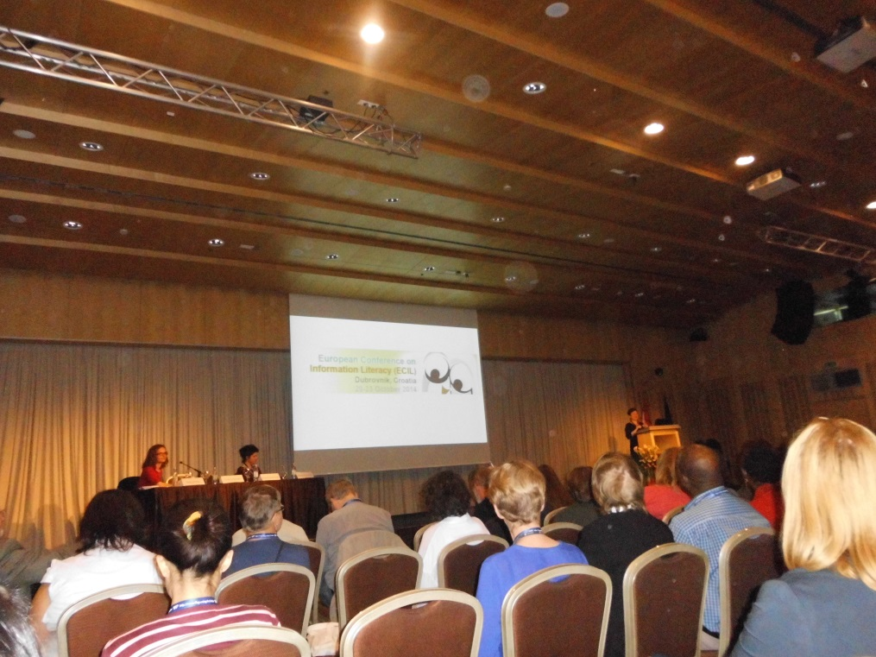
A Multinational Study on Copyright Literacy Competencies of LIS Professionals
Tania Todorova1, Tereza Тrencheva¹, Serap Kurbanoğlu², Güleda Doğan²,
Aleksandra Horvat³, and Joumana Boustany⁴

State University of Library Studies and Information Technologies
Sofia, Bulgaria
{t.todorova, t.trencheva}@unibit.bg
2 Hacettepe University, Ankara, Turkey
{serap, gduzyol}@hacettepe.edu.tr
3 University of Zagreb, Zagreb, Croatia
aleksandra.horvat@zg.htnet.hr
4 IUT Université Paris Descartes, Paris, France
Jboustany@gmail.com
Abstract. This paper presents findings from a multinational study on copyright literacy competencies of LIS (Library and Information Science) professionals. An online survey instrument was developed by the authors in order to collect data from professionals who work in cultural institutions such as libraries, archives and museums regarding their familiarity, knowledge, awareness, and opinions on copyright related issues. The survey garnered a total of 622 complete responses (148 from Bulgaria, 82 from Croatia, 311 from France and 81 from Turkey). Copyright competencies are getting more crucial for information professionals because managing and meeting copyright related challenges and trends will play a key role in shaping the future of the profession. The findings and conclusions are expected to help LIS education community, experts of professional associations, managers and other specialists from cultural heritage institutions to find out gaps in copyright competencies of information professionals and take measures to fill in this gap.
Keywords: LIS education, information literacy, copyright literacy, Bulgaria, Croatia, France, Turkey.
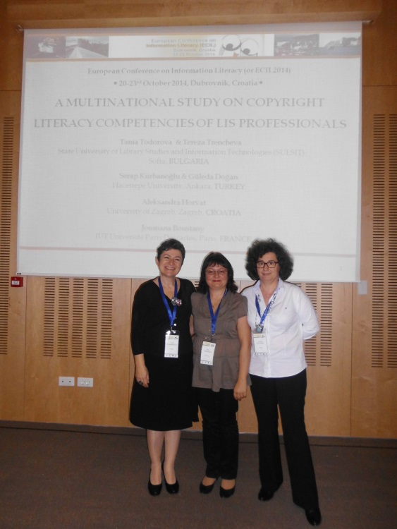
Presenters: Tania Todorova, Serap Kurbanoglu, Joumana Boustany
Afternoon Session, 20 October 2014
Session Best Practices, 22 October 2014
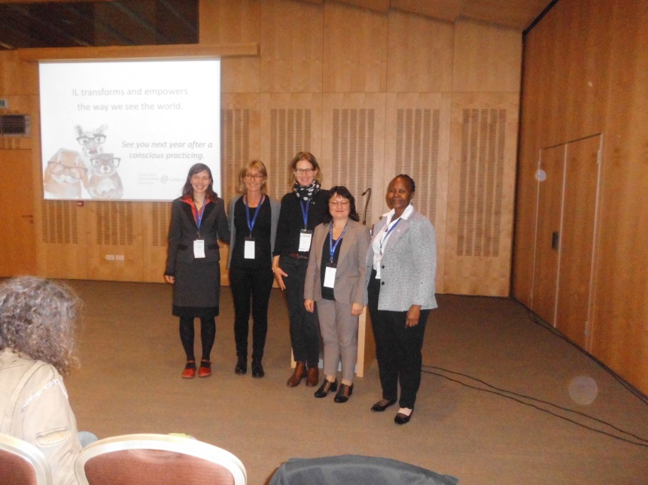
Moderator: Tania Todorova

Friendly moment
